Overview of Logistic Regression

Why Logistic?

Age | Insured
20 | 0
22 | 0
24 | 0
26 | 0
32 | 1
40 | 1
60 | 1
65 | 1
72 | 1
80 | 1
85 | 1
92 | 1
We cannot draw a straight best-fit line because the output must be between 0 and 1. Logistic regression uses a sigmoid (S-shaped) curve that fits the data better and gives the probability of being insured. The curve separates young and old ages smoothly.

Logistic Regression is used to predict a categorical target variable, usually binary (0/1).

Linear combination:

z = mx + c

Probability prediction:

p = 1 / (1 + e^-z) (Sigmoid function)

Threshold: p > 0.5 → class 1, else class 0
. Assumptions

Target variable should be binary.

No multicollinearity among predictors.

Log-odds should be linearly related to predictors.
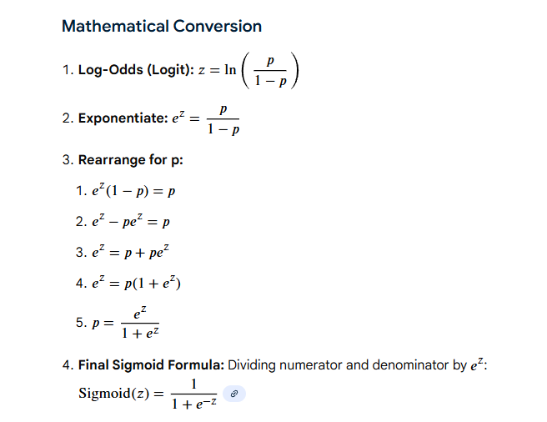

odds ratio= odds of success / odds of failure

p(A)/1-P(A)
log(odds)=log(p(A)/1-p(A))

Example :
Marks (x) | True Result | z = mx+c | Sigmoid(z) | Predicted
2 | 0 | -20 | ~0 | 0
3 | 0 | -10 | ~0 | 0
4 | 0 | -5 | ~0.006 | 0
7 | 1 | 10 | ~0.999 | 1
8 | 1 | 20 | ~1 | 1
9 | 1 | 30 | ~1 | 1

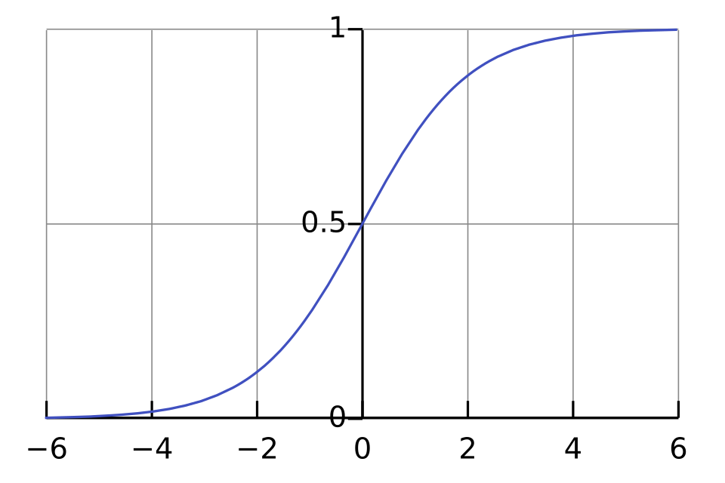

Why Logistic Regression Instead of classification

It’s called regression because the model first predicts a number, not a class.

What actually happens inside

Logistic regression does this:
z=mx+c

That part is pure regression — predicting a continuous value

z (can be -10, 5, 100, anything).
Then we convert it:

probability=sigmoid(z)

That’s still a number between 0 and 1.

Only at the very end we say:

Probability > 0.5 → Class 1

Probability ≤ 0.5 → Class 0

The classification step is just a decision rule on a number.

So the name comes from THIS ---->

Step | Type
Find relationship between marks and z | Regression
Convert to probability | Still numeric prediction
Turn probability into class | Classification step

Simple way to remember

Logistic regression = regression model used for classification

Binary cross Entropy (Loss function)

L=−[ylog(y^)+(1−y)log(1−y^)]

- Y-> Actual Result
- y^ --- prediction
Roc and AUC curve

Y_ACT | Y_PRED (Prob) | Y(0) | Y(0.2) | Y(0.4)
1 | 0.8 | 1 | 1 | 1
0 | 0.9 | 1 | 1 | 1
1 | 0.4 | 1 | 1 | 1
1 | 0.3 | 1 | 1 | 0
0 | 0.2 | 1 | 1 | 0
1 | 0.7 | 1 | 1 | 1

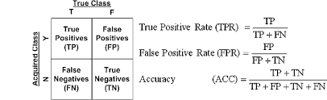​

• ROC Curve shows how model performance changes at different thresholds.
• AUC gives one number that tells how good the model is overall.

AUC value | Meaning
1.0 | Perfect model
0.9 | Excellent
0.8 | Good
0.5 | Random guessing
< 0.5 | Worse than random

